Assignment Module- 29
47. Create a table that lists 5 common tasks (like data backup, user password reset, server patching, network monitoring, and encryption key management) and clearly mark whether each is the responsibility of the cloud provider or the user in the AWS Shared Responsibility Model.
Answer: AWS Shared Responsibility Model
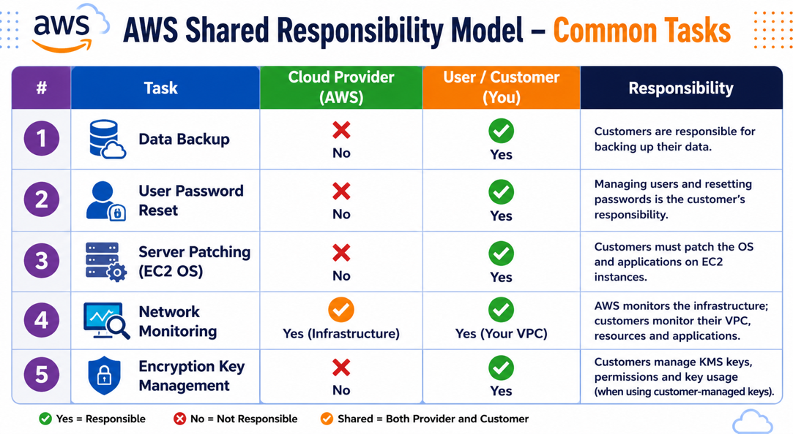
48. Log in to the AWS Management Console and create a new IAM user named 'zomato-analytics' with programmatic access only. Attach the 'AmazonS3ReadOnlyAccess' policy to this user.
Answer:
Steps:
- Sign in to the AWS Management Console.
- Go to IAM.
- Click Users → Create user.
- Enter user name: zomato-analytics
- Select: Provide user access to the AWS API - Programmatic access only
- Click Next.
- Select Attach policies directly.
- Search for: AmazonS3ReadOnlyAccess
- Check the box.
- Click Next → Create user.
- Download the Access Key ID and Secret Access Key if prompted.

49. Create a custom IAM policy in AWS named 'EC2StartStopPolicy' that allows starting and stopping EC2 instances but denies all other EC2 actions. Attach this policy to a new IAM role called 'ec2-operator'.<br><br><em><strong>Hint:</strong> Use the AWS Policy Generator or Visual Editor to specify 'ec2:StartInstances' and 'ec2:StopInstances' actions.</em>

Answer: Create Custom IAM Policy and Role

Policy Name: EC2StartStopPolicy

Policy JSON:
{
"Version": "2012-10-17",
"Statement": [
{
"Sid": "AllowStartStop",
"Effect": "Allow",
"Action": [
"ec2:StartInstances",
"ec2:StopInstances"
],
"Resource": "*"
}
]
}

Since IAM denies everything not explicitly allowed, you do not need an explicit Deny statement for other EC2 actions.

Create Role:
- IAM → Roles
- Create role
- Choose AWS Service (or as required by your assignment)
- Name: ec2-operator
- Attach: EC2StartStopPolicy
- Finish creating the role.

50. Simulate a scenario where a user tries to access an S3 bucket without the required permissions. Remove 'AmazonS3ReadOnlyAccess' from the 'zomato-analytics' user and attempt to list the bucket contents. Take a screenshot of the error message and explain in 2-3 sentences why this happened according to the Shared Responsibility Model.

Answer: Simulate S3 Permission Error

Steps:
- Open IAM.
- Select the user: zomato-analytics

- Remove: AmazonS3ReadOnlyAccess
- Save changes.
- Sign in as that user (or use its access keys with the AWS CLI).
- Attempt to list an S3 bucket:
- aws s3 ls
or
- aws s3 ls s3://your-bucket-name

Expected Error: An error occurred (AccessDenied) when calling the ListBuckets operation: Access Denied.

After removing the AmazonS3ReadOnlyAccess policy, the IAM user no longer has permission to list or read S3 buckets. AWS IAM follows a default-deny model, so any action not explicitly allowed is blocked. According to the AWS Shared Responsibility Model, customers are responsible for managing IAM permissions and ensuring users receive only the access they require.

51. Use AWS IAM Policy Simulator to test if the 'ec2-operator' role you created can terminate EC2 instances. Document the result and explain how the policy you attached enforces least privilege.

Answer:
Steps:
- Open IAM Policy Simulator.
- Select the role: ec2-operator
- Choose the service: EC2
- Select the action: ec2: TerminateInstances
- Click Run Simulation.

Expected Result:
Action | Result
ec2: TerminateInstances | Denied

Explanation: The EC2StartStopPolicy grants permission only for ec2: StartInstances and ec2: StopInstances. Because ec2: TerminateInstances is not included in the policy, IAM implicitly denies the action. This demonstrates the principle of least privilege by granting only the minimum permissions required for the role's responsibilities.

52. Create a simple text file named mynotes.txt, upload it to your Google Drive, and enable encryption for the file using any free encryption tool (such as VeraCrypt or Cryptomator). Take a screenshot of the encrypted file in your Drive.

Answer: Create mynotes.txt, Upload to Google Drive, and Encrypt It

Step 1: Create the Text File
Create a file named: mynotes.txt

Example content:
- Cloud Computing Assignment
- Student Name: __________
- Course: __________
This file is created for cloud storage and encryption practice.

Step 2: Upload to Google Drive
- Open Google Drive.
- Click New → File upload.
- Select mynotes.txt.
- Wait for the upload to finish.

Step 3: Encrypt the File
Use a free encryption tool such as Cryptomator or VeraCrypt.

Using Cryptomator:
  - Install Cryptomator.
  - Create a new encrypted vault.
  - Set a strong password.
  - Copy mynotes.txt into the vault.
  - Lock the vault.
  - Upload the encrypted vault folder to Google Drive.

Explanation: The file was encrypted before or while being stored in cloud storage. Encryption ensures that even if someone gains unauthorized access to the cloud storage, the file contents remain unreadable without the encryption password.

53. Set up an automatic daily backup for a folder containing your college assignments to a cloud storage service like Google Drive or Dropbox. Verify that at least one backup copy is created in the cloud.

Answer:
Using Google Drive for Desktop:

- Install Google Drive for Desktop.
- Sign in with your Google account.
- Open Preferences.
- Click Add Folder.
- Select your College Assignments folder.
- Choose:
- Back up to Google Drive
- Save the settings.

The folder will now automatically synchronize whenever changes occur.

Verify Backup:
- Open Google Drive and verify that your assignments folder appears with at least one file inside.

Explanation: Automatic backups protect important academic files from accidental deletion, hardware failure, or system crashes by maintaining a synchronized copy in cloud storage.

54. Sign up for an AWS Free Tier account, create a new CloudWatch dashboard, and add a metric widget that monitors the CPU utilization of an EC2 instance (use a test instance if needed).

Answer:
Steps:

  - Sign in to the AWS Console.
  - Launch a Free Tier EC2 instance (if you do not already have one).
  - Open CloudWatch.
  - Click Dashboards.
  - Click Create dashboard.
  - Dashboard name: EC2-Monitoring
  - Add a Metric Widget.
  - Select: EC2
  - Choose metric: CPUUtilization
  - Select your EC2 instance.
  - Click Create Widget.
  - Save the dashboard.

55. Configure an alarm in AWS CloudWatch that sends you an email notification if your EC2 instance CPU usage goes above 60%. <br><br><em><strong>Hint:</strong> Use the 'Create Alarm' option in CloudWatch and set the threshold to 60% for CPUUtilization.</em>

Answer:
Steps:
- Open CloudWatch.
- Select Alarms.
3.Click Create Alarm.
4. Select metric: EC2 → Per-Instance Metrics → CPUUtilization
5. Choose your EC2 instance.
6. Set:
Setting | Value
Threshold Type | Static
Condition | Greater than
Value | 60

7. Create an SNS topic (if prompted).
8. Enter your email address.
9. Confirm the email subscription.
10. Finish creating the alarm.

Expected Result: Whenever CPU utilization exceeds 60%, AWS sends an email notification.

Explanation: The CloudWatch alarm continuously monitors the EC2 instance's CPU utilization. When the CPU usage exceeds the configured threshold of 60%, CloudWatch triggers the alarm and sends an email notification through Amazon SNS, enabling administrators to respond quickly to high resource utilization.

56. Use AWS CloudWatch Logs to create a log group and push a sample log event (for example, a login attempt or app error message). Confirm that the log appears in your CloudWatch console.

Answer:
Step 1
Open
CloudWatch

Step 2
Navigate to
Logs

Step 3
Create Log Group
Example name: Application Logs

Step 4
Create a Log Stream
Example: TestLogStream

Step 5
Add Sample Log Event
Example log:

Timestamp: 2026-07-07 18:30:00

Message: User login attempt from IP 192.168.1.20
or
Application Error: Database connection timeout.

Step 6
Save the log event.

Explanation: CloudWatch Logs collects and stores application and system logs in a centralized location. This enables administrators to monitor system activity, troubleshoot errors, and analyze events for operational and security purposes.

57. Create a table comparing GDPR, HIPAA, and PCI DSS by listing at least three key requirements of each standard relevant to cloud security.

Answer:
Standard | Key cloud security requirements
GDPR | Encrypt or pseudonymize personal data; ensure confidentiality, integrity, availability, and resilience; restore access after incidents; regularly test security controls. GDPR Article 32 requires “appropriate technical and organisational measures” based on risk.
HIPAA | Protect ePHI using administrative, physical, and technical safeguards; ensure confidentiality, integrity, and availability of health data; control access to systems handling ePHI.
PCI DSS | Protect cardholder data; restrict access by business need; use strong authentication and access controls; monitor and test networks regularly. PCI DSS is maintained by the PCI Security Standards Council for payment data protection.

58. Log in to AWS and open AWS Trusted Advisor. Run a scan for your account and take a screenshot of the dashboard showing at least three checks (e.g., Security Groups, MFA on Root Account, S3 Bucket Permissions).

Answer: Log in to AWS → search Trusted Advisor → open the dashboard → run/refresh checks.

Trusted Advisor Check | Status
Security Groups – Specific Ports Unrestricted | Add your result
MFA on Root Account | Add your result
S3 Bucket Permissions | Add your result

59. Pick one flagged security issue from your AWS Trusted Advisor scan (such as an open S3 bucket or missing MFA). Describe why this issue could violate GDPR, HIPAA, or PCI DSS compliance, and suggest a specific action to remediate it.

Answer:
Example issue: MFA is not enabled on the AWS root account.

This is a security risk because the root account has full administrative access. If compromised, an attacker could access, delete, or expose personal data, health data, or cardholder data. This could create compliance problems under GDPR because GDPR requires appropriate security controls for personal data, and under HIPAA because access to ePHI must be protected with technical safeguards.

60. Enable MFA (Multi-Factor Authentication) on your AWS root account if it is not already enabled and write a short note explaining how this step helps with compliance under at least one of the standards discussed.

Answer: Enabling MFA strengthens account security by requiring a second verification factor in addition to the password. This helps prevent unauthorized access to cloud resources and supports compliance with standards like GDPR, HIPAA, and PCI DSS because all three expect strong access control and protection of sensitive data.

61. After resolving at least one security issue flagged by AWS Trusted Advisor, rerun the scan and document the before-and-after status. Explain in 2-3 sentences how using Trusted Advisor supports ongoing cloud compliance monitoring. <br><br><em><strong>Hint:</strong> Focus on how automated tools help you stay compliant with changing requirements. </em>

Answer:
Issue | Before | Action Taken | After
MFA on Root Account | Warning / Red | Enabled MFA | Green / Resolved

Using AWS Trusted Advisor supports ongoing cloud compliance monitoring by automatically checking common security risks such as weak access controls, exposed storage, and insecure network settings. Regular scans help organizations detect issues early and keep cloud environments aligned with changing compliance requirements.

62. Draw a network diagram for a music streaming app (like Spotify) showing how you would segment user traffic, admin traffic, and backend services using VLANs to isolate each group.

Answer:
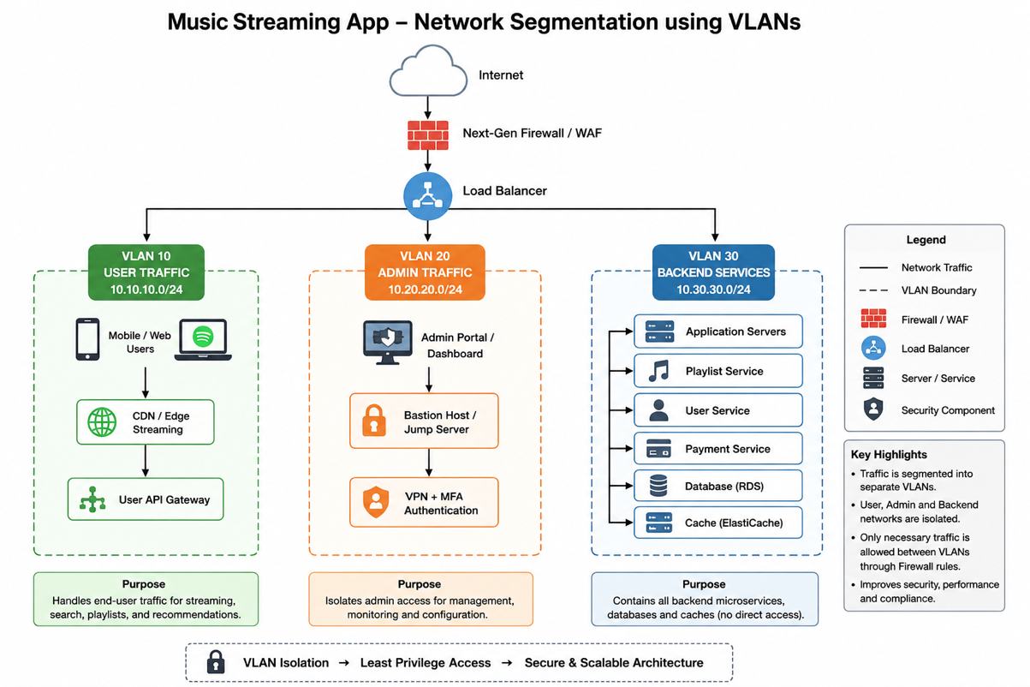

63. Configure a sample IAM policy (in JSON format) that allows a user to read playlists but not modify or delete them in a cloud-based music app. <br><br><em><strong>Hint:</strong> Use AWS IAM syntax and specify the allowed and denied actions clearly. </em>

Answer: AWS IAM Policy: Read Playlists Only
{
"Version": "2012-10-17",
"Statement": [
{
"Sid": "AllowReadPlaylists",
"Effect": "Allow",
"Action": [
"musicapp:GetPlaylist",
"musicapp:ListPlaylists"
],
"Resource": "arn:aws:musicapp:us-east-1:123456789012:playlist/*"
},
{
"Sid": "DenyPlaylistModification",
"Effect": "Deny",
"Action": [
"musicapp:CreatePlaylist",
"musicapp:UpdatePlaylist",
"musicapp:DeletePlaylist"
],
"Resource": "arn:aws:musicapp:us-east-1:123456789012:playlist/*"
}
]
}

AWS IAM supports explicit Allow and Deny, and an explicit deny overrides an allow.

64. Write a short scenario describing how an IDS (Intrusion Detection System) could detect suspicious activity in a Zomato-style food ordering platform and explain what kind of alert it should generate.

Answer: Zomato-Style Food Ordering Platform
An IDS could monitor traffic between the customer app, restaurant dashboard, payment service, and order database. If one customer account suddenly sends hundreds of login attempts, SQL injection patterns, or unusual API calls such as trying to access another user’s order history, the IDS would detect it as suspicious.

Alert generated: “High Severity Alert: Possible brute-force login or API abuse detected from IP address X targeting customer login/order API.”

65. Pick any cloud security tool (like AWS Guard Duty, Azure Security Center, or Google Security Command Center) and describe how you would use it to monitor for unauthorized access in a Flipkart-like e-commerce platform.

Answer: AWS Guard Duty for Flipkart-Style Platform

For a Flipkart-like e-commerce platform, I would enable AWS Guard Duty to monitor CloudTrail logs, VPC Flow Logs, DNS logs, IAM activity, and S3 activity. Guard Duty continuously analyzes AWS activity and generates findings for suspicious or potentially unauthorized behavior.

Example use: if an IAM access key is used from an unusual location or identified as potentially compromised, Guard Duty can generate a finding with API calls, timestamps, source IP, and access key details.

66. Use ChatGPT to generate a checklist of at least 7 steps for designing a secure architecture for a social media app (like Instagram) that combines VLANs, IDS/IPS, IAM, and cloud security tools. Paste the checklist and mention one thing you would add, or change based on your own understanding.

Answer:
- Separate user, admin, and backend traffic using VLANs or private subnets.
- Place public-facing services behind a load balancer and web application firewall.
- Use IAM roles with least-privilege permissions.
- Enable MFA for admins and privileged users.
- Deploy IDS/IPS to detect brute-force attacks, malware traffic, and API abuse.
- Encrypt user photos, messages, and passwords at rest and in transit.
- Use Guard Duty or a similar cloud security tool for continuous threat monitoring.
- Store databases in private networks with no direct internet access.
- Log all admin actions and sensitive API requests.
- Regularly review security alerts, IAM permissions, and network rules.

One thing ChatGPT would add: ChatGPT would add rate limiting for login, posting, and messaging APIs to reduce spam, brute-force attacks, and bot activity.

67. List the 5 main phases of the Ethical Hacking Framework and write one line describing the goal of each phase.

Answer:

Phase | Goal
1. Reconnaissance (Information Gathering) | Collect information about the target system, network, or application before testing.
2. Scanning & Enumeration | Identify open ports, services, operating systems, users, and potential vulnerabilities.
3. Gaining Access (Exploitation) | Exploit identified vulnerabilities to verify whether unauthorized access is possible.
4. Maintaining Access (Post-Exploitation) | Assess how an attacker could maintain persistence and evaluate the impact of the compromise.
5. Covering Tracks & Reporting | In ethical hacking, explain how attackers might hide evidence, then document findings and recommend security improvements (ethical hackers do not actually conceal malicious activity).

68. Imagine your Instagram account was compromised and suspicious posts appeared. Identify 3 types of digital evidence you would collect from your device to help a forensics team investigate.

Answer: If suspicious posts appeared on my Instagram account, I would collect the following digital evidence:

Device System Logs:
Login history, timestamps, IP addresses, and security event logs from the device.

Browser History and Cookies:
Records of Instagram login sessions, saved cookies, and browsing activity related to the account.

Screenshots and Account Activity:
Screenshots of suspicious posts, login alerts, account activity, emails from Instagram, and notification history.

69. Given a sample Windows event log file (trainer will provide), analyze it to find the timestamp and username of the last successful login before a suspicious activity occurred. <br><br><em><strong>Hint:</strong> Look for Event ID 4624 in the log entries. </em>

Answer: To identify the last successful login, I need the Windows event log file that your trainer provides.

Steps:
- Open the log in Event Viewer or another log analysis tool.
- Filter for Event ID 4624 (Successful Logon).
- Find the last Event ID 4624 before the suspicious event.
- Record:
- Timestamp
- Username (Account Name)
Result Format:
Timestamp | Username
(From your log file) | (From your log file)

70. Simulate a Zomato account compromise: create a simple text file 'zomato_log.txt' with 10 fake login attempts (mix of successful and failed). Write steps to perform a basic forensic analysis to identify which attempts were successful and which failed and summarize your findings.

Answer: zomato_log.txt

2026-07-07 09:10:15, user01, FAILED
2026-07-07 09:12:20, user02, SUCCESS
2026-07-07 09:15:44, user03, FAILED
2026-07-07 09:18:07, user01, SUCCESS
2026-07-07 09:20:35, user04, FAILED
2026-07-07 09:22:11, user05, SUCCESS
2026-07-07 09:25:42, user02, FAILED
2026-07-07 09:27:15, user06, SUCCESS
2026-07-07 09:30:10, user07, FAILED
2026-07-07 09:35:58, user08, SUCCESS

Basic Forensic Analysis Steps:

- Preserve the original log file.
- Review each login entry.
- Separate SUCCESS and FAILED login attempts.
- Count successful and failed logins.
- Check for repeated failures from the same user.
- Review timestamps for unusual login patterns.
- Document findings and recommend further investigation if necessary.

Summary of Findings
Result Count:
Successful Logins | 5
Failed Logins | 5

Successful Attempts:
- user02 – 09:12:20
- user01 – 09:18:07
- user05 – 09:22:11
- user06 – 09:27:15
- user08 – 09:35:58

Failed Attempts:
- user01 – 09:10:15
- user03 – 09:15:44
- user04 – 09:20:35
- user02 – 09:25:42
- user07 – 09:30:10

71. Use ChatGPT or Bing AI to generate a checklist of 7 key steps for performing a basic digital forensic analysis on a compromised system. Paste the checklist and mention one step you would add or modify for investigating a social media account hack.

Answer:
- Secure and isolate the compromised system to prevent further changes.
- Document the incident, including the date, time, and initial observations.
- Create a forensic image of the storage media without modifying the original evidence.
- Collect system logs, application logs, browser history, and network logs.
- Analyze user accounts, login records, and suspicious processes.
- Correlate timestamps to reconstruct the sequence of events.
- Prepare a detailed forensic report with evidence, findings, and recommendations.

Additional Step for a Social Media Account Investigation
ChatGPT would add:
Review account security information, including recent login locations, connected devices, password changes, recovery email/phone changes, and enabled third-party applications. This helps determine whether the account was accessed from an unauthorized device or through a malicious connected app.

